The 2018 EEE Technical Advisory Board (TAB) meeting will be held on May 9th 2018 (Wednesday) at the Museum, Central Building, we take great pleasure in inviting you to our meeting.

The EEE Technical Advisory Board Meeting is an important regular meeting in EEE and could benefit the departmental development in terms of both research and teaching. Some established professionals have confirmed their attendance on the meeting, including the CEO and Member of the board of Fujitsu Research Center China, Principal Group Engineering Manager, Deputy Director of Microsoft Suzhou, and VP, CTO of the Flight Business Unit, Ctrip.

The theme of this board meeting has been set as “AI and its impact on electrical electronic engineering”. The four invited VIP talks will be given:

VIP Talk1:  Title: AI activity summary in Fujitsu R&D Center  Speaker: Dr. Satoshi Naoi, Fellow, Fujitsu Laboratories Ltd. CEO & Member of the Board, Fujitsu R&D Center  Language: English  Location: Museum, Central Building  Time: 10:20 – 10:40 | 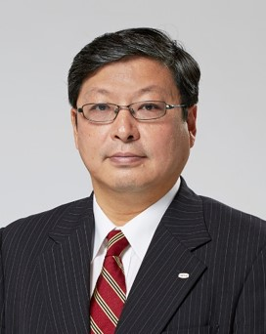
VIP Talk2:  Title: R&D progress of information technology in Fujitsu R&D Center  Speaker: Dr. Jun Sun, Principal Researcher, Director, Fujitsu R&D Center  Language: English  Location: Museum, Central Building  Time: 10:40 – 11:10 | 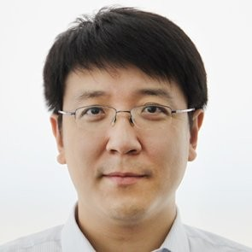
VIP Talk3:  Title: Improve User Experience with Travel Intelligence  Speaker: Dr. Yudong Tan, VP, CTO of the Flight Business Unit, Ctrip.  Language: English  Location: Museum, Central Building  Time: 11:10 – 12:00 |  | 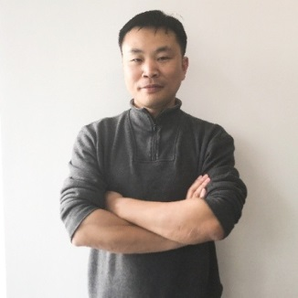
VIP Talk4:  Title: Deep learning for multimedia applications  Speaker: Dr. Jimin Xiao, Lecturer, PD of MMT  Language: English  Location: EE 505, EE building  Time: 13:30 – 14:10 |  | 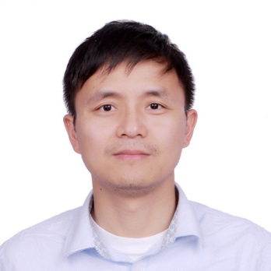

EEE Technical Advisory Board Meeting
-AI and its Impact on EEE

Date: May 9th, 2018
Morning Session: Location: Museum, Central Building, XJTLU
9:00 AM | Reception
9:20 AM | Welcome Speech: Prof. David Goodman, VP, XJTLU.
9:30 AM | Group Photo
9:40 AM | Department introduction: Prof. Kaizhu Huang, EEE HoD.
10:00 AM | Coffee Break
10:20 AM | Speaker: Dr. Satoshi Naoi, Fellow, Fujitsu Laboratories Ltd. CEO & Member of the Board, Fujitsu R&D Center  Title: AI activity summary in Fujitsu R&D Center
10:40 AM | Speaker: Dr. Jun Sun, Principal Researcher, Director, Fujitsu R&D Center  Title: R&D progress of Information Technology in Fujitsu R&D Center
11:10 AM | Speaker: Dr. Yudong Tan, VP, CTO of the Flight Business Unit, Ctrip  Title: Improve User Experience with Travel Intelligence
Lunch (12:00 AM-13:30 PM): South campus, XJTLU
Afternoon Session: Location: EE505, XJTLU
13:30 PM | Speaker: Dr. Jimin Xiao, Lecturer, PD of MMT  Title: Deep learning for multimedia applications
14:10 PM | Meeting with Students
14:40 PM | Coffee Break
15:00 PM | Lab Tour
16:00 PM | Board Discussion
17:00 PM | Dinner

